* **MAULANA AZAD NATIONAL INSTITUTE OF TECHNOLOGY**

**Name:** Vivek Kumar Ahirwar **Scholar No:** 191112419

**Department:** CSE **Section:**3

**Semester:** 4th**Subject:** Java Lab

**Date:** 06-02-2021 **Subject Code:** CSE230

JAVA: LAB-ASSIGNMENT 1

1. Write a JAVA program to calculate the factorial of a number, input should be given though the command line argument.

**public** **class** factorial {

**public** **static** **void** main(String[] args) {

// **TODO** Auto-generated method stub

**long** n,fact=1;

n=Long.*parseLong*(args[0]);

**for**(**int** i=1;i<=n;i++)

{

fact=fact*i;

}

System.***out***.println(fact);

}

}

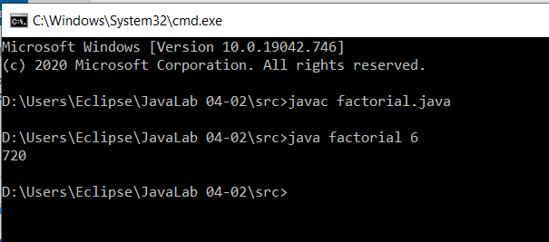

2. Write a JAVA program to initialize and display the attribute values of a class “vehicle” variables using constructor.

**public** **class** Vehicle {

String vehicle_type, vehicle_number, vehicle_model, vehicle_color;

**long** price, reg_number;

**public** Vehicle(String vehicle_type, String vehicle_number, String vehicle_model, String vehicle_color, **long** price,

**long** reg_number) {

**this**.vehicle_type = vehicle_type;

**this**.vehicle_number = vehicle_number;

**this**.vehicle_model = vehicle_model;

**this**.vehicle_color = vehicle_color;

**this**.price = price;

**this**.reg_number = reg_number;

}

**void** display() {

System.***out***.println("Vehicle type: " + vehicle_type);

System.***out***.println("Vehicle number: " + vehicle_number);

System.***out***.println("Vehicle model: " + vehicle_model);

System.***out***.println("Vehicle color: " + vehicle_color);

System.***out***.println("Vehicle price: " + price);

System.***out***.println("Registration number: " + reg_number);

}

**public** **static** **void** main(String[] args) {

// **TODO** Auto-generated method stub

Vehicle veh = **new** Vehicle("Car", "MP13FE1919", "M-CLS", "GREY", 9090000, 8519119);

veh.display();

}

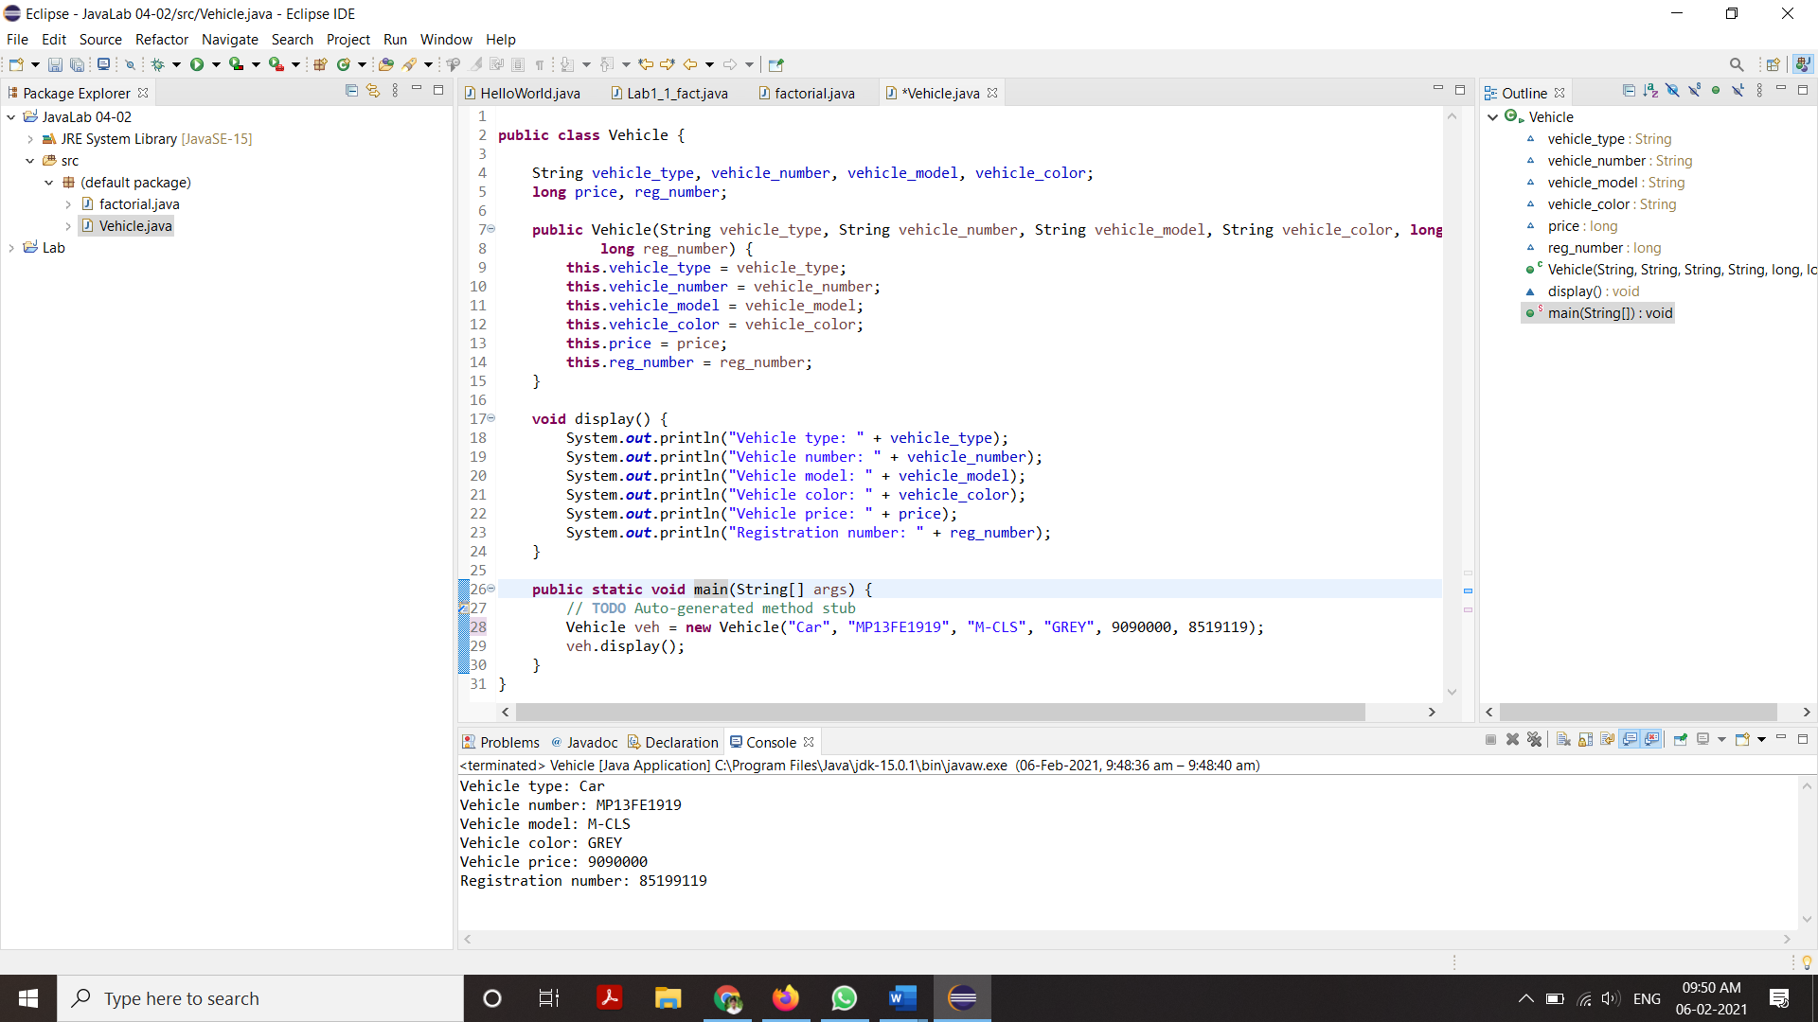}

3. Create an interface ‘vehicle’ and implement the methods of the interface in class ‘bike’ to get and display the attribute values.

*Vehicle_interface.java*

**public** **interface** Vehicle_interface {

**public** **void** modelDetails();

**public** **void** priceDetails();

}

*Bike.java*

**public** **class** Bike **implements** Vehicle_interface{

String vehicle_name, vehicle_number, vehicle_model, color;

**long** price, reg_number;

**public** Bike(String vehicle_name, String vehicle_number, String vehicle_model, String color, **long** price,

**long** reg_number) {

**this**.vehicle_name = vehicle_name;

**this**.vehicle_number = vehicle_number;

**this**.vehicle_model = vehicle_model;

**this**.color = color;

**this**.price = price;

**this**.reg_number = reg_number;

}

**public** **void** modelDetails() {

System.***out***.println("Vehicle name: " + vehicle_name);

System.***out***.println("Vehicle number: " + vehicle_number);

System.***out***.println("Vehicle model: " + vehicle_model);

System.***out***.println("Vehicle color: " + color);

System.***out***.println();

}

**public** **void** priceDetails() {

System.***out***.println("Price: " + price);

System.***out***.println("Registration number: " + reg_number);

}

**public** **static** **void** main(String[] args) {

Bike b = **new** Bike("Bajaj Pulsar RS200", "MP13JF1919", "P19RS200", "White", 301000, 19192519);

b.modelDetails();

b.priceDetails();

}

}

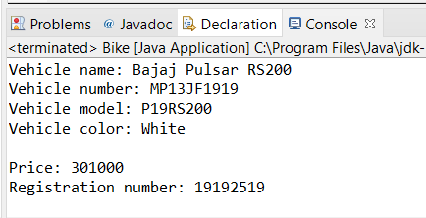

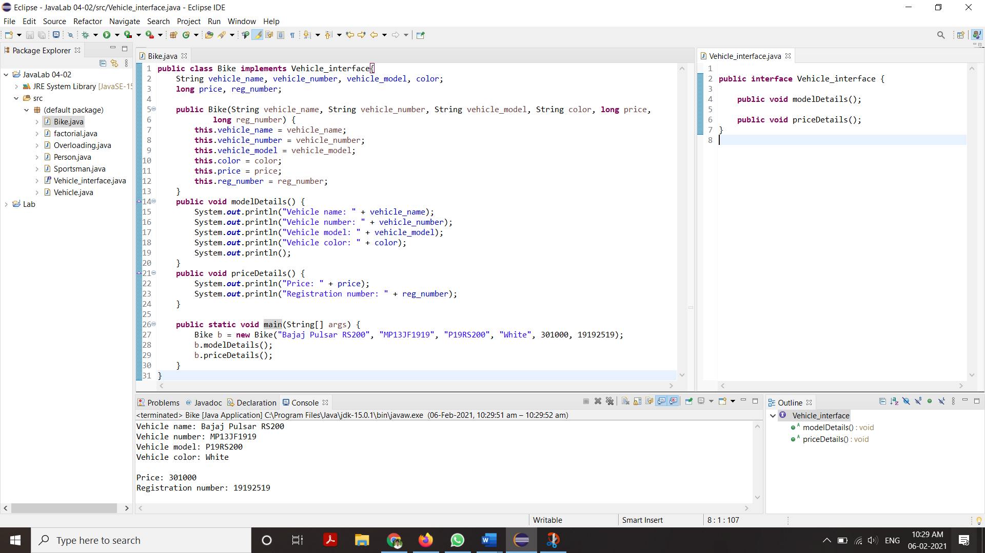

4. Write a JAVA program, in which create a sportsman class that inherits the class person to initialize the basic attributes of a sportsman object.

*Person.java*

**public** **class** Person {

String name;

**double** height, weight;

**int** age;

**public** Person() {

name = "";

height = 0;

weight = 0;

age = 0;

}

**public** Person(String name, **double** height, **double** weight, **int** age) {

**this**.name = name;

**this**.height = height;

**this**.weight = weight;

**this**.age = age;

}

**public** **void** display() {

System.***out***.println("Name: " + name);

System.***out***.println("Height: " + height);

System.***out***.println("Weight: " + weight);

System.***out***.println("Age: " + age);

}

}

*Sportsman.java*

**public** **class** Sportsman **extends** Person {

String sport;

**char** gender;

**public** Sportsman(String name, **double** height, **double** weight,

**int** age, String sport, **char** gender) {

**super**(name, height, weight, age);

**this**.sport = sport;

**this**.gender = gender;

}

**public** **void** display() {

**super**.display();

System.***out***.println("Sport: " + sport);

System.***out***.println("Gender: " + gender);

}

**public** **static** **void** main(String[] args) {

// **TODO** Auto-generated method stub

Sportsman s = **new** Sportsman("Ronaldo", 179, 70, 30, "Football", 'M');

s.display();

}

}

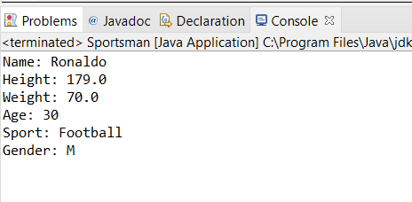

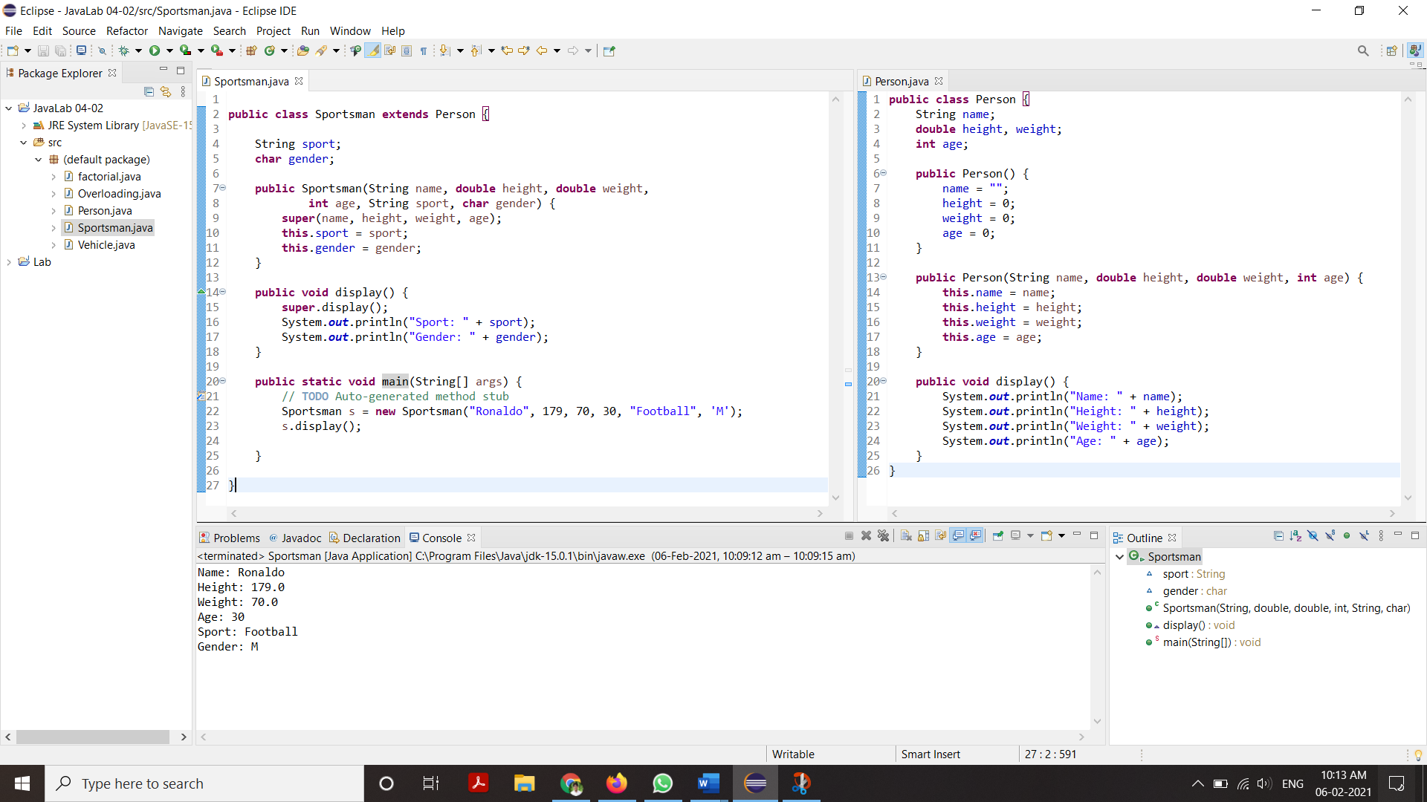

5. Create a JAVA program to perform method overloading to perform addition of float and integer numbers.

**public** **class** Overloading {

**public** **int** add(**int** x, **int** y) {

**return** x + y;

}

**public** **float** add(**float** x, **float** y) {

**return** x + y;

}

**public** **static** **void** main(String[] args) {

// **TODO** Auto-generated method stub

Overloading m = **new** Overloading();

System.***out***.println("Sum of 1 and 9 is: " + m.add(1, 9));

System.***out***.println("Sum of 1.7 and 9.5 is: " + m.add(1.7f, 9.5f));

}

}

